CLOud Development A: Part 1
Full Name: Kandyce Smit Student Number: ST10467645

Lecturer: Farshida Wania
Module Code: CLDV6221

Contents
YouTube and GitHub Link: 2
YouTube Demo Video Link: 2
GitHub Link: 2
A. Design the EventBase Database 3
ERD for EventEase 3
Accompanying Database Script for EventEase from SSMS 4
C. Local Persistence Setup 8
Screenshot of appsettings.json configuration that points to local database instance: 8
Screenshot of app running on local host: 8
D. Cloud Computing Basics 11
1. Cloud vs On-Premises Deployment 11
2. IaaS, PaaS, and SaaS – Key Differences and EventEase's Best Option 14
References 17

YouTube and GitHub Link:

YouTube Demo Video Link:
- https://youtu.be/z-IS1aD39M0

GitHub Link:
- https://github.com/EMGPSD/cldv6211-g1-2026-part1-ST10467645.git

Design the EventBase Database

ERD for EventEase

The following ERD was drawn using draw.io

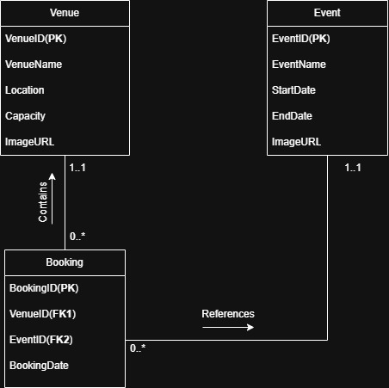

Accompanying Database Script for EventEase from SSMS

- The initial database script did not include the ImageURL attribute in the Event table. Upon review, this was identified as a requirement and subsequently added using an ALTER TABLE statement

Initial database script:

Create database ST10467645_EventEase;

USE ST10467645_EventEase;

CREATE TABLE Venue (
VenueID INT IDENTITY (1, 1) PRIMARY KEY,
VenueName VARCHAR(100) NOT NULL,
Location VARCHAR(150) NOT NULL,
Capacity INT NOT NULL,
ImageURL TEXT NOT NULL
);

CREATE TABLE Event (
EventID INT IDENTITY (1, 1) PRIMARY KEY,
EventName VARCHAR(100) NOT NULL,
StartDate DATE NOT NULL,
EndDate DATE NOT NULL
);

CREATE TABLE Booking (
BookingID INT IDENTITY (1, 1) PRIMARY KEY,
VenueID INT NOT NULL,
EventID INT NOT NULL,
BookingDate DATE NOT NULL,
CONSTRAINT FK_Booking_Venue
FOREIGN KEY (VenueID) REFERENCES Venue(VenueID),
CONSTRAINT FK_Booking_Event
FOREIGN KEY (EventID) REFERENCES Event (EventID)
);

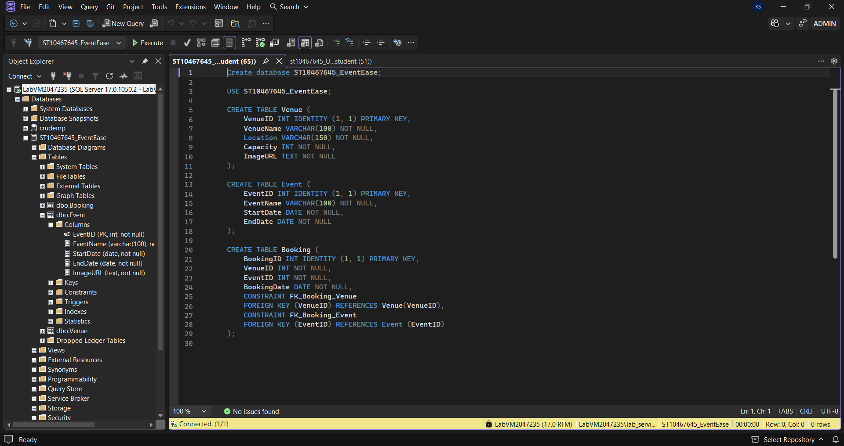

The following SQL statement was used to add the missing ImageURL attribute to the Event table:

USE ST10467645_EventEase;

ALTER TABLE Event
ADD ImageURL TEXT NOT NULL;

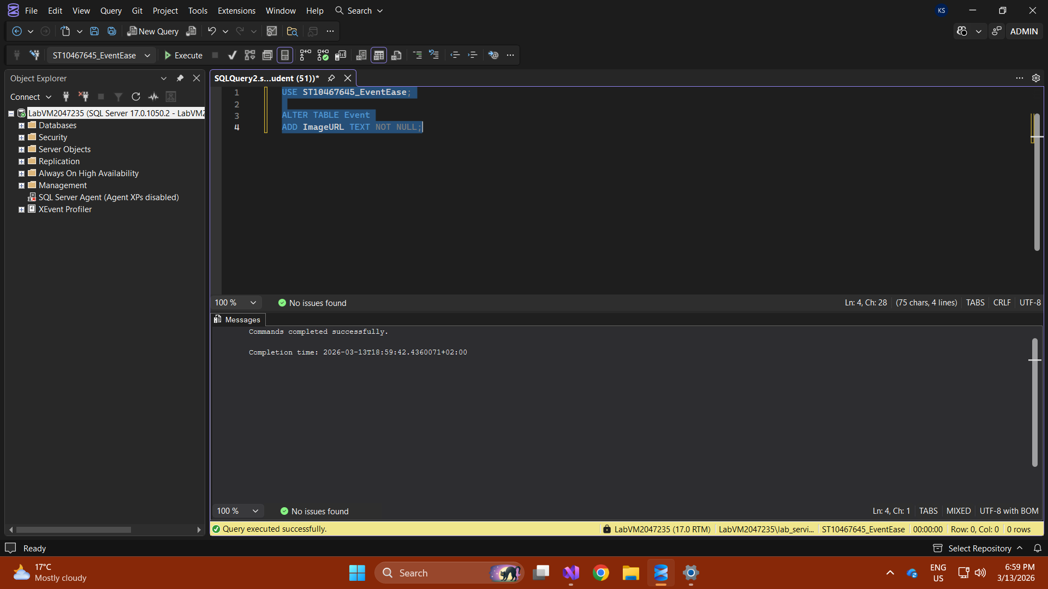

Sample data was manually inserted into each table to populate the application with initial records upon startup, as required.:

USE ST10467645_EventEase;

-- Insert sample Venues
INSERT INTO Venue (VenueName, Location, Capacity, ImageURL)
VALUES
('Grand Hall', 'Johannesburg', 500, ' https://phgcdn.com/images/uploads/STLUS/masthead/hero_grandhall.png'),
('Garden Pavilion', 'Cape Town', 200, 'https://encrypted-tbn0.gstatic.com/images?q=tbn:ANd9GcT_3HuQxqcl_sIC3iU_szQPWd7xzq8aRckb0A&s');

-- Insert sample Events
INSERT INTO Event (EventName, StartDate, EndDate, ImageURL)
VALUES
('Annual Gala', '2026-04-01', '2026-04-01', ' https://images.quicket.co.za/0547874_0.jpeg'),
('Tech Conference', '2026-05-15', '2026-05-16', 'https://www.techrepublic.com/wp-content/uploads/2022/05/top-5-conferences-2022-tom.jpeg');

SELECT VenueID FROM Venue;

SELECT EventID FROM Event;

-- Insert sample Bookings
INSERT INTO Booking (VenueID, EventID, BookingDate)
VALUES
(6, 6, '2026-03-15'),
(7, 7, '2026-03-20');

Local Persistence Setup

Screenshot of appsettings.json configuration that points to local database instance:

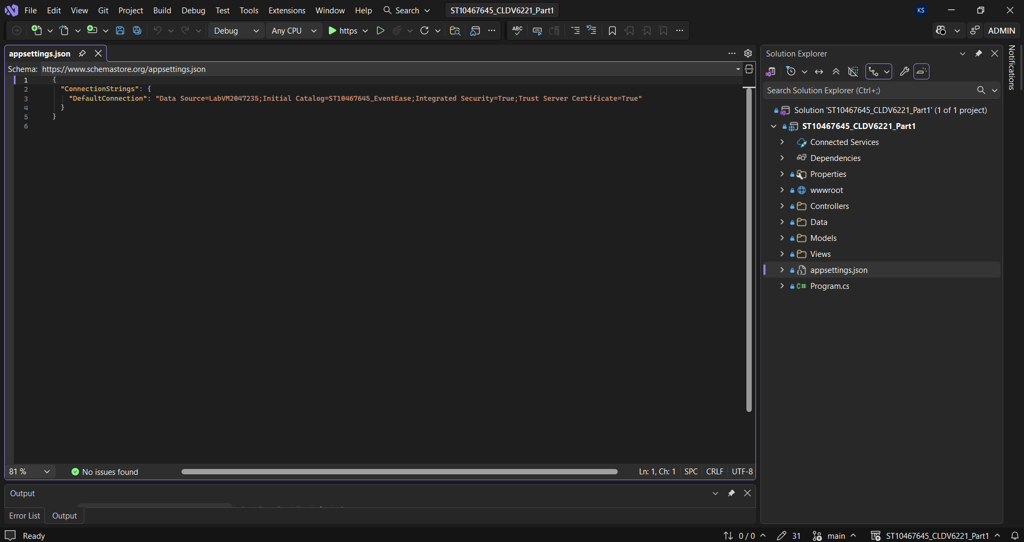

Screenshot of app running on local host:

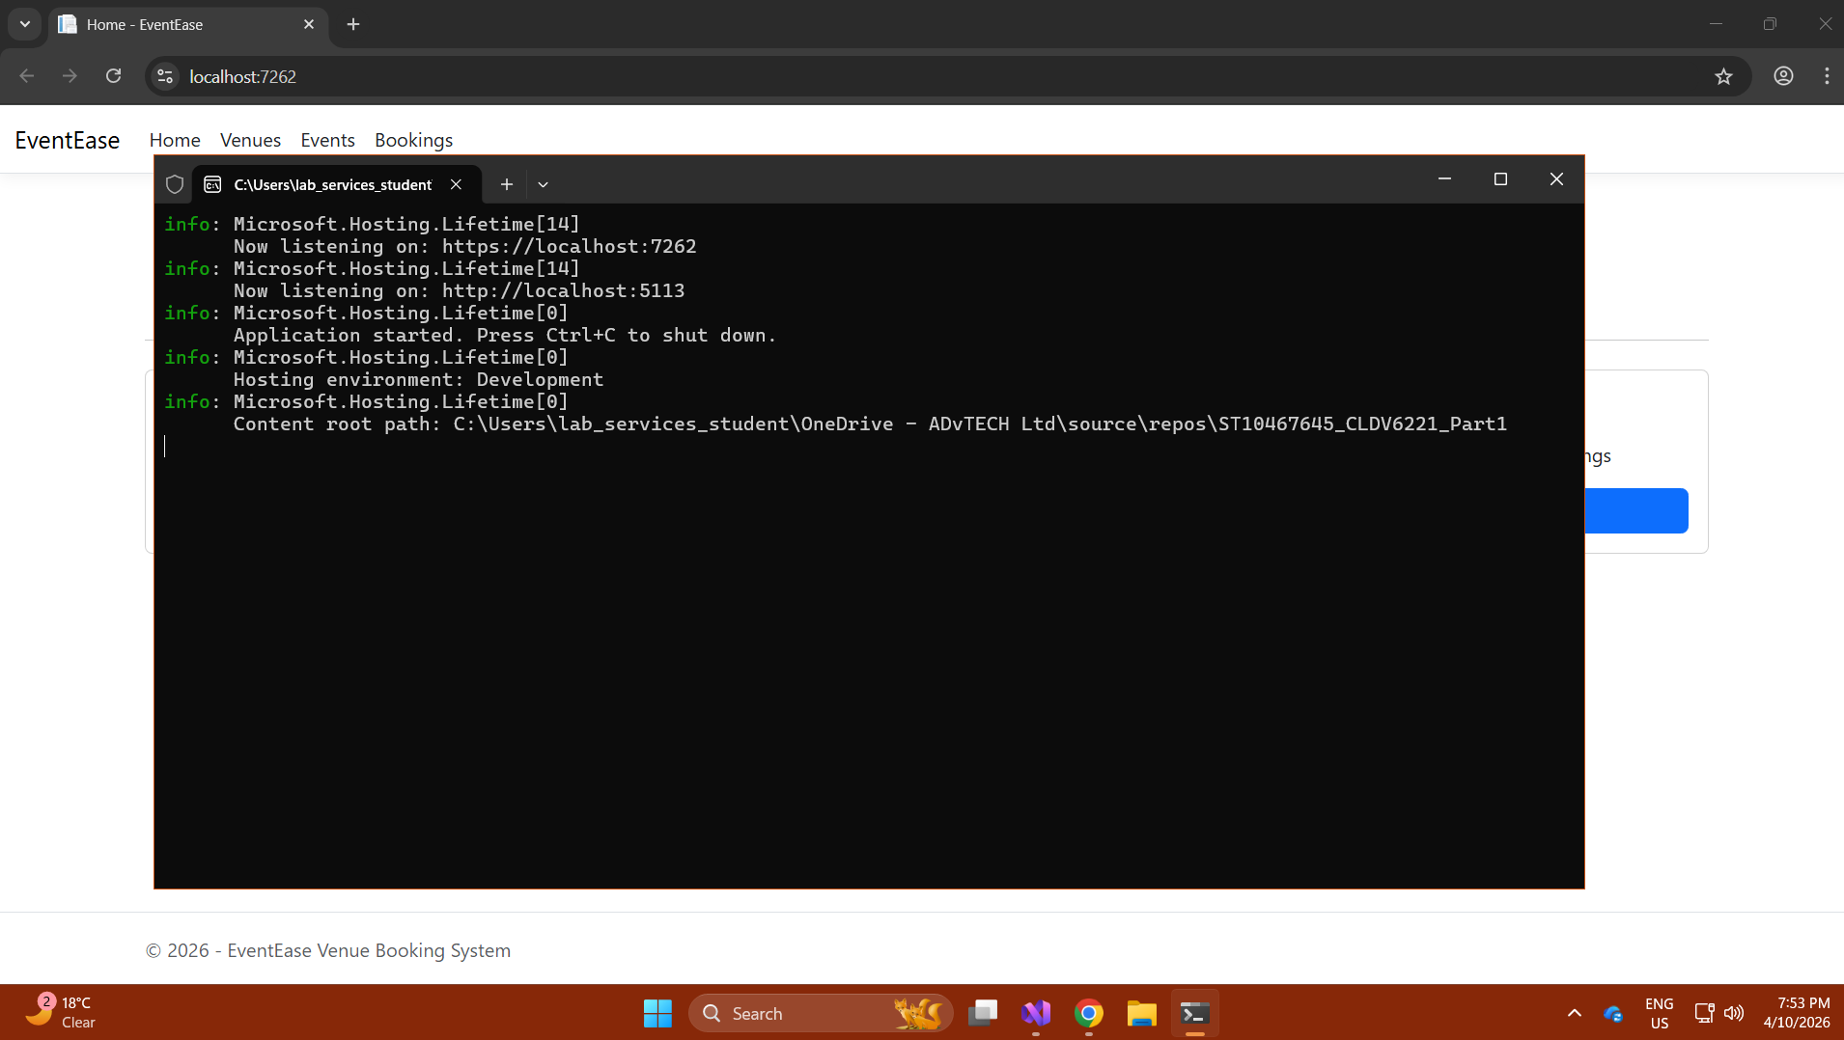
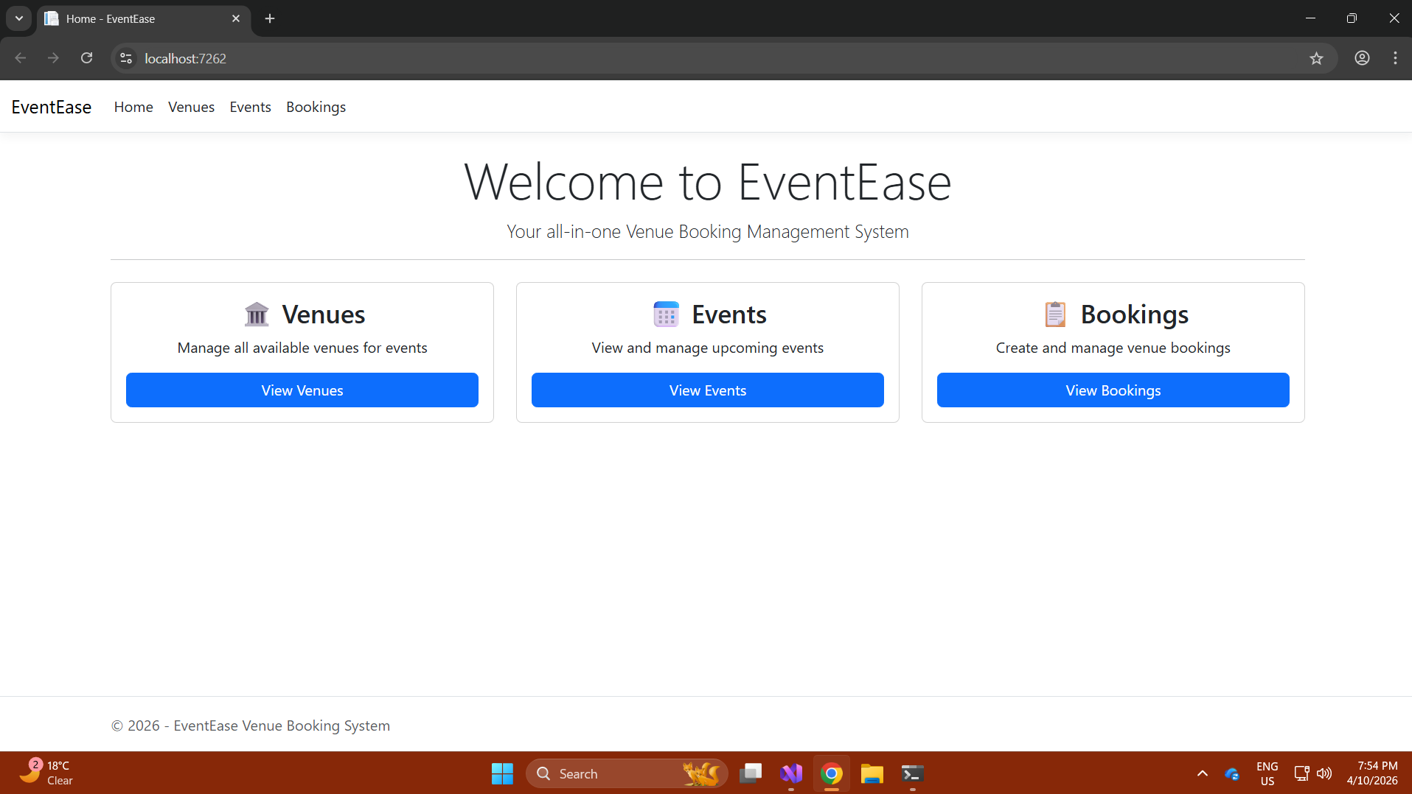

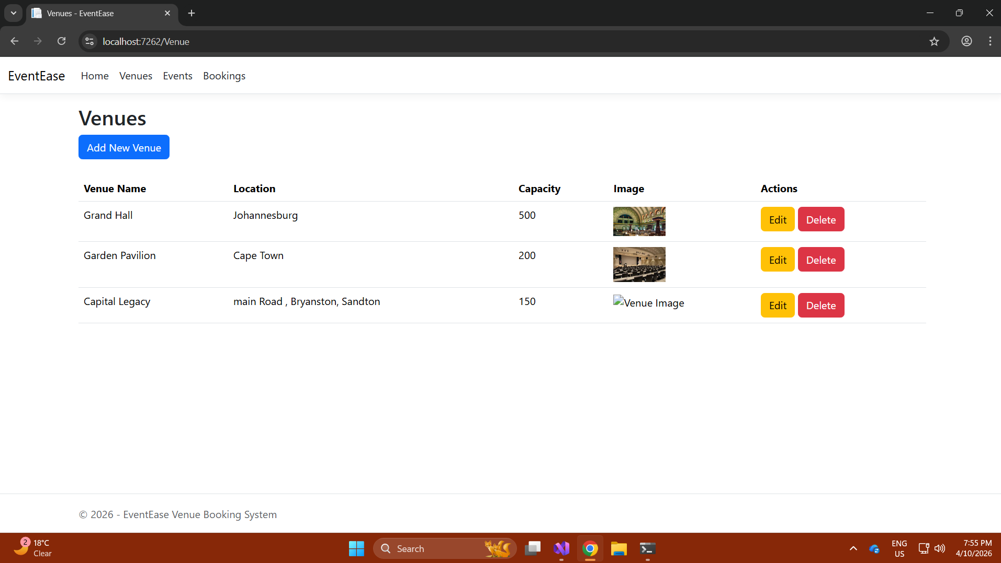

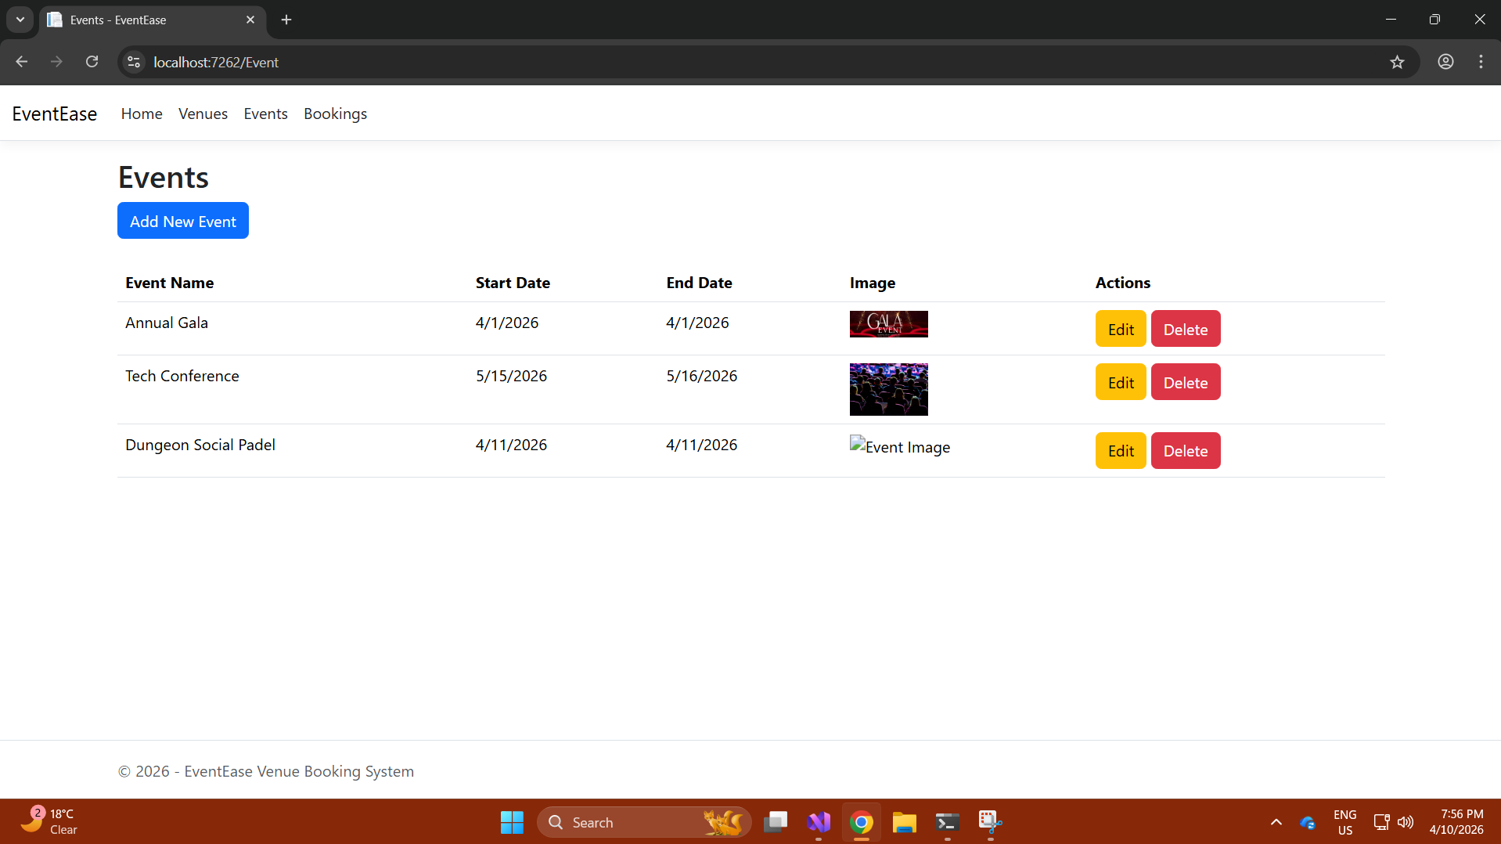

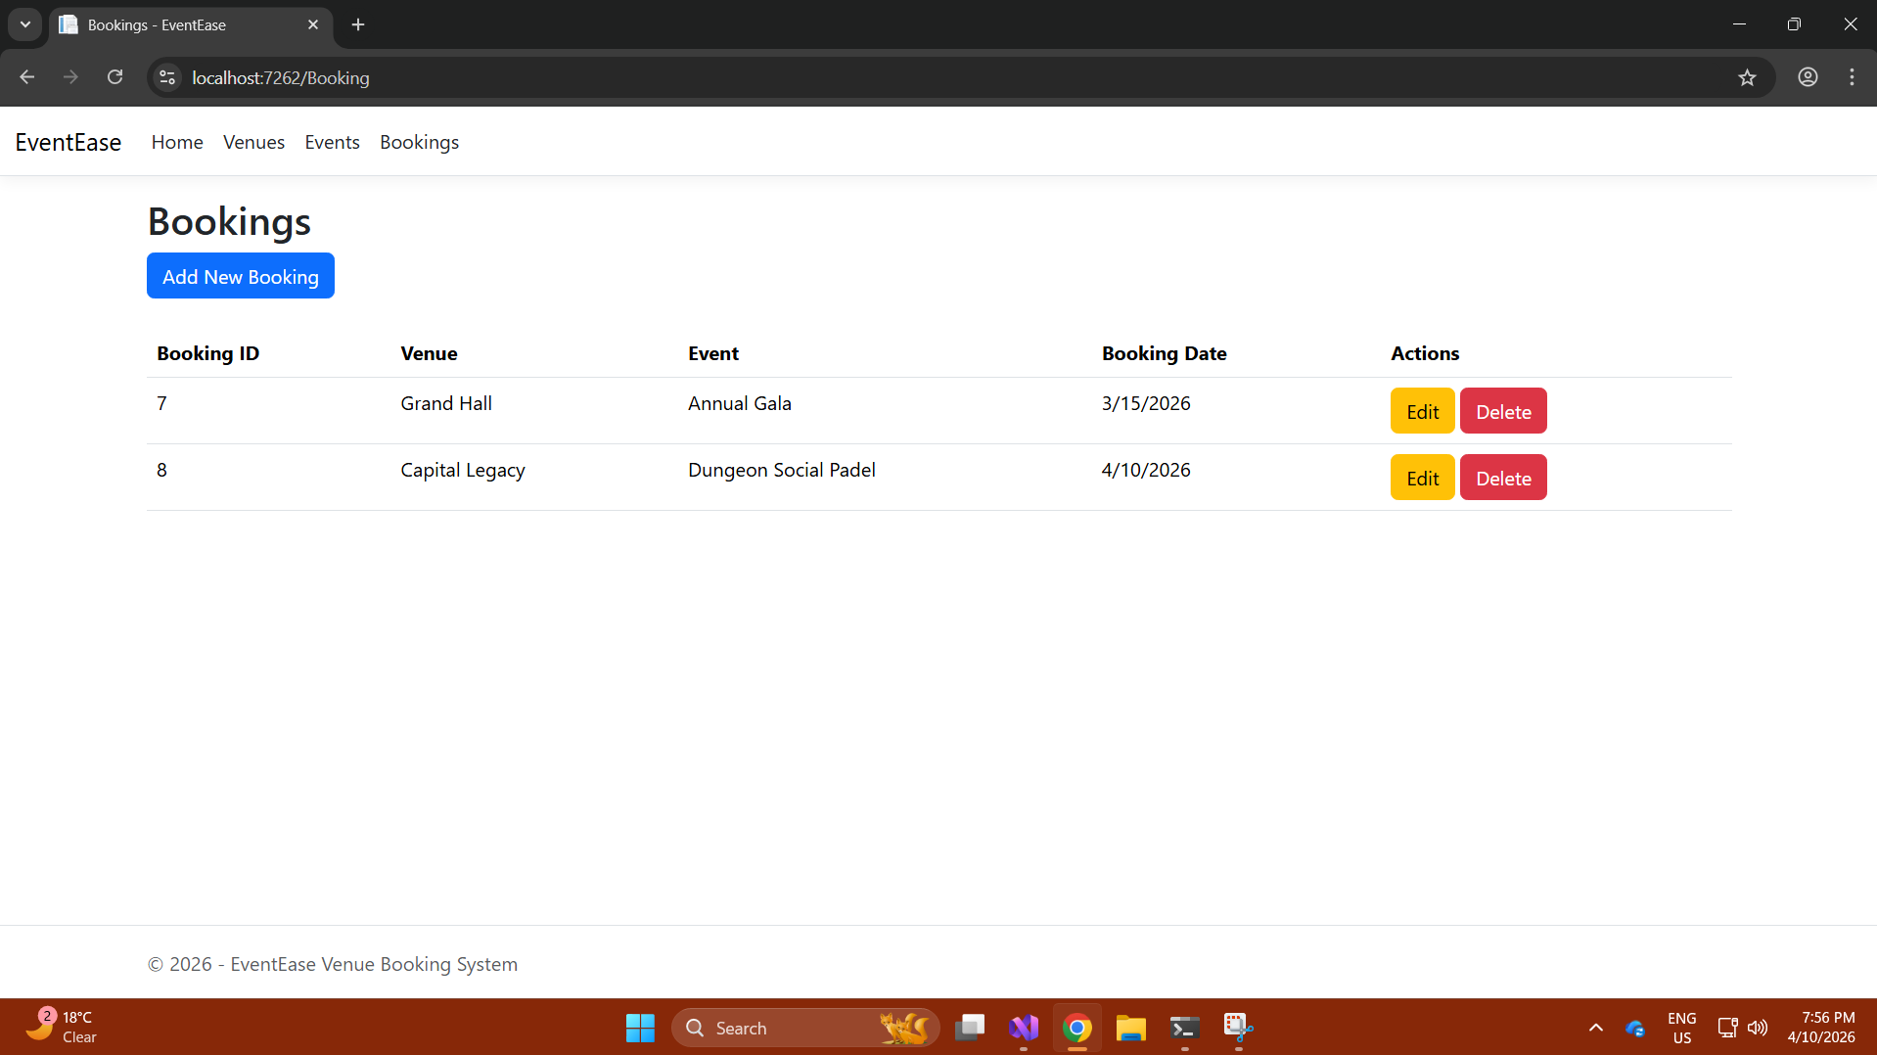

Cloud Computing Basics

Cloud vs On-Premises Deployment
The first decision point for any system such as the EventEase Venue Booking Platform is choosing where the platform will be hosted. There are two primary methods for hosting systems, deploy in the cloud or deploy on premises, and these have many differences in terms of security, deployment time, and the way resources are managed.

1.1 Security
Security is likely the area of greatest debate when considering the pros and cons of each deployment method. On premises provides the organisation with total ownership and direct control over all the data, servers, and physical infrastructure used by the organisation. This means that the organisation’s internal IT department is ultimately responsible for managing firewalls, antivirus software, software updates, and access controls. In some cases, this high degree of control may be advantageous for organisations whose data falls under highly regulated industries or classifications (Cleo, n.d.). A good example of this is banking systems or classified government applications where legally mandated complete isolation from all external networks is required.
On the other hand, providing the level of security that is provided in an on-premises environment is expensive and requires a lot of organisational resources. Organisations need to hire and train adequate security personnel to continually monitor and audit the systems, provide timely updates and patches, and ensure that no vulnerabilities exist in the system. Many smaller organisations, such as EventEase’s development team, may not have the resources. In contrast, deploying systems in the cloud shifts a large portion of the responsibility for security back to the cloud providers. As illustrated in Figure 1, cloud and on-premises deployments differ significantly in their security responsibilities, with cloud providers managing most of the security infrastructure. Cloud providers such as Microsoft Azure have invested heavily in security. As cloud providers operate automated vulnerability scanning, implement patches rapidly, and provide dedicated cybersecurity professionals, cloud-based security solutions provide centralised visibility and continuous monitoring capabilities that would require significant resources to replicate within an organisation (Svitla Systems, 2025). Cloud-based platforms also include integrated identity management solutions, built-in data encryption solutions, and regulatory compliance tools.
Therefore, the advantages in terms of cloud security do exist but also so do the disadvantages. A shared infrastructure in a multi-tenant cloud environment means there is potential for a breach against one tenant to affect others as well. Additionally, organisations have less control over their own security because they are giving away control to a third party for security (Avigilon, 2025). Since EventEase will be storing booking data and venue data that is not extremely sensitive, this represents a level of security offered by the cloud that is both satisfactory and potentially better than EventEase would be able to build and maintain on their own.
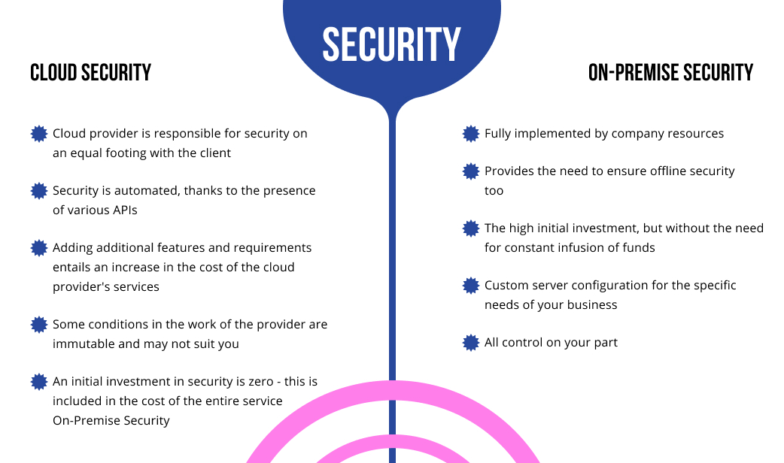
Figure 1: Cloud vs On-Premises Security Comparison (CodeIT, 2021).

1.2 Deployment Speed
Another area in which the two options differ is in terms of deployment speed. The process of setting up an on-premises environment is complex and takes many weeks or even months of procurement of the necessary hardware; installation of the appropriate OS and software; configuration of the network; and extensive testing of all components prior to being able to deploy a single line of application code. Furthermore, when additional capacity is needed, such as if EventEase's booking platform were to receive a large influx of bookings at one time, Event Ease would need to order and deliver new servers, install them, and configure them as well. All these steps add to delays (HyperSense Software, 2025).
In contrast, deploying to the cloud is much faster. Once you create an account with a service provider such as Microsoft Azure, you can immediately start creating virtual machines, configuring databases, and publishing web applications. With Azure App Service for example, a developer can publish an ASP.NET Core MVC application with just a few mouse clicks right out of Visual Studio. There is no hardware to purchase and no physical infrastructure to configure. As illustrated in Figure 2, cloud deployment significantly reduces setup time compared to on-premises environments, which can take weeks or months to implement. The rapid deployment capabilities of the cloud allow for much quicker times from development to production. This is especially important for a growing business like Event Ease that requires a high degree of flexibility and speed in responding to changing requirements (Microsoft Azure, n.d.).
A real-world example of this speed benefit was observed during the COVID-19 pandemic, when businesses, such as Zoom, were able to rapidly scale their cloud-based infrastructure to accommodate massive increases in user numbers, growing from tens of millions per day to hundreds of millions in a few weeks, something that could never have been accomplished using an on premises model (AccuKnox, 2025).

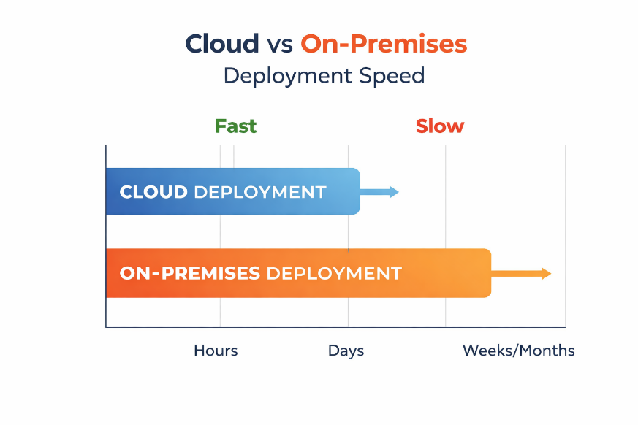

Figure 2: Cloud vs On-Premises Deployment Speed generated using ChatGPT (ChatGPT, 2026).

1.3 Resource Management
In a typical on-premises environment, the organisation owns and operates the entire array of physical equipment. Therefore, organisations need to carefully plan for the capacity needed for the upcoming period, so if they underestimate the usage of their systems, there may be insufficient capacity to meet the load, and if they overestimate, they are paying for unused capacity with wasted capital. Organisations operating in on-premises environments must always maintain excess CPU, memory and disk capacity available in their data center for each component of their systems or purchase additional hardware that will take months to arrive and implement (HyperSense Software, 2025).
By nature, cloud-based infrastructure is elastic. As illustrated in Figure 3, cloud elasticity provides advantages such as flexibility, scalability, cost efficiency, and rapid resource allocation. The amount of any given resource can be dynamically adjusted upward or downward, depending upon demand, and customers only pay for those resources that they utilise. Customers of cloud providers do not incur maintenance or overhead expenses related to their utilisation of the cloud provider’s infrastructure and the cost of those resources is dynamic and depends upon the customer’s consumption level (Cleo, n.d.). For EventEase, this is very practical because, at times of high demand, such as during festival seasons or large corporate event bookings, the booking platform can automatically increase capacity to meet the high demand for service and then automatically decrease capacity once the demand returns to normal levels, therefore saving on unnecessary overhead costs.
In addition, cloud-based providers deliver managed services for database management, storage, and networking, therefore reducing the number of tasks required to be performed by a development team relative to developing features and maintaining the booking platform. Instead of spending valuable time and resources concerned with the proper maintenance of a SQL server or storage arrays, the team can focus entirely on adding value to the business through feature enhancements to the booking platform. This represents a substantial advantage for a small development team that must remain fast and focused (Scale Computing, 2025).

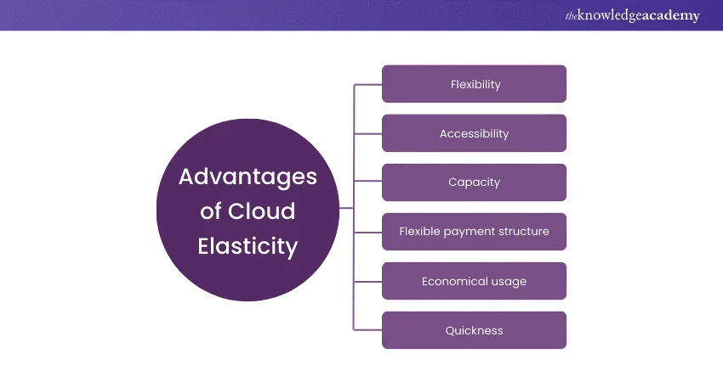
Figure 3: Advantages of Cloud Elasticity (TheKnowledgeAcademy, 2026).

IaaS, PaaS, and SaaS – Key Differences and EventEase's Best Option
Cloud computing isn't one thing; it encompasses many models of services that provide varying levels of control, responsibilities for management, and degrees of abstraction. There are three primary service models in use today: Infrastructure as a Service (IaaS), Platform as a Service (PaaS), and Software as a Service (SaaS). Therefore, it is very important to understand how these models differ so that an organisation can determine which model will best support the organisations current and future requirements:

2.1 Infrastructure as a Service (IaaS)
IaaS is the most basic form of cloud services. IaaS provides virtualized computing resources, for example, servers, storage, networking, which is provided over the Internet. However, you retain full control and responsibility for everything that exists above the provided resources such as the operating system, middleware, runtime environment, application, and data. The provider typically handles the hardware, and you have complete control over the operating system, and everything built on top of it (Microsoft Azure, n.d.).
A simple example of using IaaS is by using Microsoft Azure Virtual Machines or Amazon Web Services Elastic Compute Cloud (EC2). For instance, a startup might choose to use IaaS to rapidly increase its server capacity when experiencing increased traffic without having to purchase additional physical hardware (GeeksforGeeks, 2025) However, using IaaS requires a strong technical team, in this case, personnel who must configure, secure, and manage all the resources created with the IaaS.

2.2 Platform as a Service (PaaS)
PaaS is positioned at the second tier of the cloud computing stack. In contrast to IaaS, where the customer is responsible for the entire infrastructure (servers, operating systems, networking, runtime environments), PaaS allows customers to focus solely on developing, deploying, and managing their applications while the provider maintains and manages the underlying infrastructure. PaaS enables companies to develop, test, deploy, run, update, and scale applications more quickly and inexpensively than they would with an on-premises development and management platform (IBM, 2025).
PaaS services examples include Microsoft's Azure App Service, Google's App Engine, and Amazon Web Services' Elastic Beanstalk. For a software development firm to create an application on one of these platforms they do not have to think about configuring servers, networks, or storage (GeeksforGeeks, 2025). This makes PaaS especially suitable for development groups who wish to write their application code without having to manage their infrastructure.

2.3 Software as a Service (SaaS)
SaaS is the highest abstraction layer of the cloud model. The vendor provides everything: infrastructure, platform, application, and data and the clients just use the software via a web browser (usually by subscription). Clients do not need installation; there is no maintenance required and clients do not have to worry about any infrastructure at all. The most common SaaS examples include Microsoft 365, Salesforce and Zoom (GeeksforGeeks, 2025). SaaS is most effective for end-users who need to use software, not build it.
The primary differences among the three cloud models are how much control and responsibility are provided to each client. When a client has the most control and therefore the most responsibility is when using IaaS. On the other hand, when a client has the least amount of control and therefore the least amount of responsibility is when using SaaS. Therefore, as you go up the cloud stack the cloud vendor takes over the most responsibility and performs the most maintenance and support functions providing the most out-of-the-box solutions (Datacamp, 2025). As illustrated in Figure 4, the three cloud service models differ in terms of benefits, challenges, and levels of control, with IaaS offering the most control and SaaS offering the least.

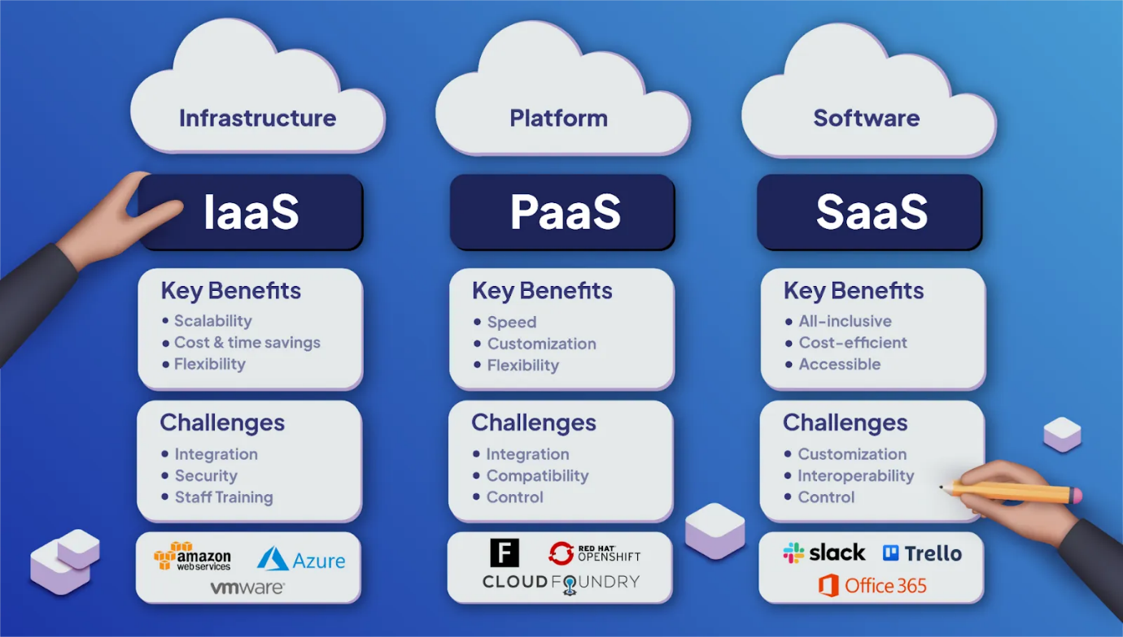
Figure 4: IaaS, PaaS and SaaS Responsibility Model (ThinkLogic, 2021).

2.4 Why PaaS is the Best Fit for EventEase
When EventEase will eventually migrate to the cloud then PaaS will be the best fit for EventEase due to the following reasons:
Firstly, EventEase is developing a custom ASP.NET Core MVC application utilising a SQL database and Azure Blob Storage for images which is exactly what PaaS was designed for. Therefore, by using Azure App Service, the development team does not have to touch virtual machines, operating systems, or network configurations. As illustrated in Figure 5, Azure provides a wide range of platform services that support application development, data management, and scalability without requiring direct management of underlying infrastructure. In fact, the platform will configure all of that, so the development team can concentrate solely on the booking logic, validation and search functionality (Microsoft Azure, n.d.).
Secondly, using a PaaS model removes most of the operational work that would be needed for IaaS. If EventEase chose to use IaaS they would have responsibility over configuring and patching the operating system on their virtual machine, managing the run time environment, installing the database server, and securing the network properly. This would be a significant distraction to a small team focused on developing a product and could introduce unnecessary risk in terms of how configurations are done (IBM, 2025).
Thirdly, at this stage, SaaS is not appropriate for EventEase as they have a bespoke, custom-built application for their booking platform, therefore it is not off-the-shelf software. Off-the-shelf software products cannot be customised to the degree required by EventEase's specific requirements around booking conflict prevention, venue image management, and admin-only access (Microsoft Azure, n.d.).
In summary, PaaS provides the right balance for EventEase, with the ability to build and deploy a fully custom application, while eliminating the operational complexity associated with managing underlying infrastructure. When EventEase grows and scalable its operations, Azure App Service and azure SQL database, both PaaS solutions, will also scale alongside it with minimal additional configuration or cost.

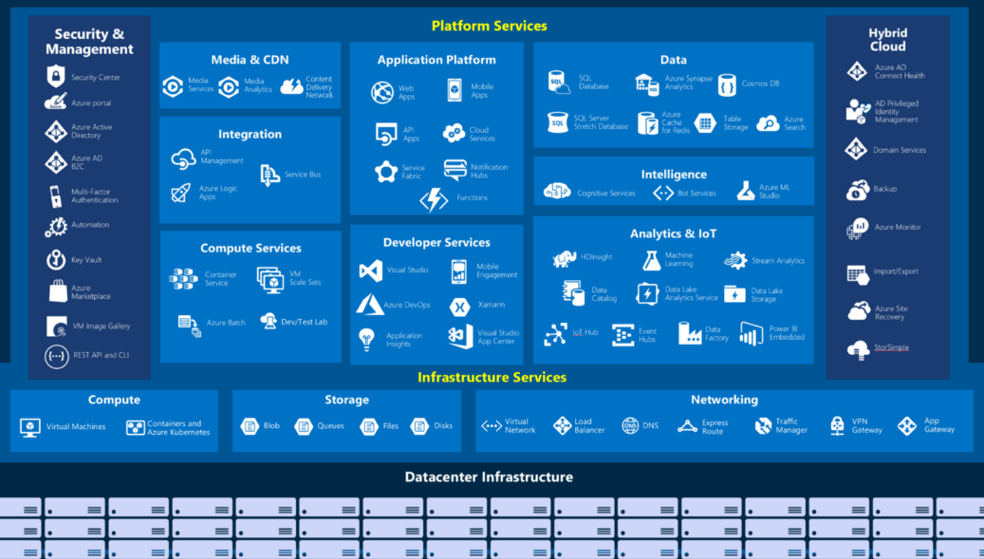
Figure 5: Microsoft Azure Service Ecosystem showing Platform and Infrastructure Services (AzureGuru, 2020).

References
AccuKnox, 2025. Cloud vs OnPremise Security: What’s Better for Your Business? Consider 3 Factors – Security, Cost and Scalability. [Online]
Available at: https://accuknox.com/blog/cloud-vs-onpremise-security
[Accessed 04 March 2026].
Avigilon, 2025. Cloud vs. on-premise security solutions: How to choose the right system. [Online]
Available at: https://www.avigilon.com/blog/cloud-vs-on-premise-security
[Accessed 04 March 2026].
AzureGuru, 2020. Types of cloud services. [Online]
Available at: https://www.azureguru.org/types-of-cloud-services/
[Accessed 10 April 2026].
ChatGPT, 2026. AI generated image. [Online]
Available at: https://chat.openai.com/
[Accessed 10 April 2026].
Cleo, n.d. On Premise vs. Cloud: Key Differences, Benefits and Risks. [Online]
Available at: https://www.cleo.com/blog/knowledge-base-on-premise-vs-cloud
[Accessed 04 March 2026].
CodeIT, 2021. On-premise vs Cloud hosting: a comparative analysis. [Online]
Available at: https://codeit.us/blog/on-premise-vs-cloud-hosting-a-comparative-analysis
[Accessed 10 April 2026].
Datacamp, 2025. Cloud Service Models Explained: IaaS, PaaS, and SaaS. [Online]
Available at: https://www.datacamp.com/blog/cloud-service-models
[Accessed 04 March 2026].
GeeksforGeeks, 2025. SaaS, PaaS and IaaS. [Online]
Available at: https://www.geeksforgeeks.org/software-engineering/difference-between-iaas-paas-and-saas/
[Accessed 04 March 2026].
HyperSense Software, 2025. Cloud vs. On-Premise Infrastructure: Comparison Guide for IT Leaders. [Online]
Available at: https://hypersense-software.com/blog/2025/07/31/cloud-vs-on-premise-infrastructure-guide/
[Accessed 04 March 2026].
IBM, 2025. IaaS, PaaS, SaaS: What's the difference?. [Online]
Available at: https://www.ibm.com/think/topics/iaas-paas-saas
[Accessed 04 March 2026].
Microsoft Azure, n.d. What are IaaS, PaaS, and SaaS?. [Online]
Available at: https://azure.microsoft.com/en-us/resources/cloud-computing-dictionary/what-are-iaas-paas-and-saas
[Accessed 04 March 2026].
Scale Computing, 2025. Cloud vs. On-Premises: Which IT Infrastructure Fits Best?. [Online]
Available at: https://www.scalecomputing.com/resources/cloud-vs-on-premises
[Accessed 04 March 2026].
Svitla Systems, 2025. Cloud vs On-premises Security: 7 Key Differences. [Online]
Available at: https://svitla.com/blog/cloud-vs-on-premises-security/
[Accessed 04 March 2026].
TheKnowledgeAcademy, 2026. What is Cloud Elasticity: A Brief Understanding. [Online]
Available at: https://www.theknowledgeacademy.com/blog/what-is-cloud-elasticity/
[Accessed 10 April 2026].
ThinkLogic, 2021. SaaS vs PaaS vs IaaS: What’s the Difference & How To Choose. [Online]
Available at: https://www.thinklogic.com/post/saas-vs-paas-vs-iaas-whats-the-difference-how-to-choose
[Accessed 10 April 2026].

